VaporWorx
We Give You Gas

WARNING
Working with fuel is dangerous. If fuel is handled improperly it can lead to fires and death. It is imperative above anything else that all appropriate safety measures be used to control the fuel and any ignition sources, including static electricity, heat, sparks, and any other sources. Proper high-pressure fuel lines and connections must be used in accordance to the manufacturer’s specifications and routed away from any potential sources of heat, ignition, and protected from mechanical damage. If you are unsure about your work or safety, stop work immediately and consult with a qualified automotive technician and/or safety official.

Instructions for Installing the VaporWorx P/N FPRAGM5 Fuel Pressure Regulator Adapter into the GM P/N 19208719 or Camaro ZL1 P/N 13579899/19258436 Fuel Module.

The Vaporworx fuel pressure regulator adapter (FPRA) allows the fuel pressure regulator from a 4th-gen LS1 powered Camaro to be used in a 5th-gen Camaro fuel module. Delphi P/N FP10021 and FP10075 are two readily available aftermarket fuel pressure regulators that should work well. These regulators, when used with the Vaporworx FPRA, will allow a standard 58psi fuel pressure output curve similar to that of the Corvette C5 fuel pressure regulator/filter.

STEP 1: On the lower/side of the fuel module is a circular device held in by a wire retainer. This is the 5th-gen stock fuel poppet valve that must be removed. Using a screwdriver, carefully remove the retaining wire and ground strap. See Photo 1.

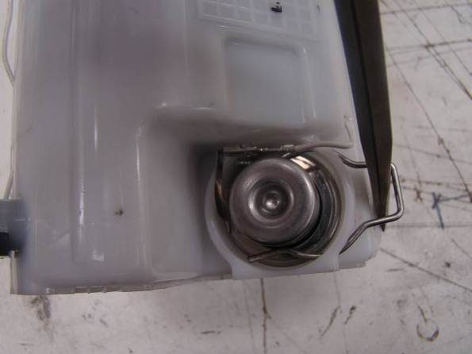
Photo 1: Note the ground strap ring that is located under the retaining wire. Do not use excessive force.

STEP 2: Using a pair of large Channel Lock pliers, twist the fuel pressure regulator and pull it away from the module to dislodge it as seen in Photo 2. A slight rocking motion can also be used.

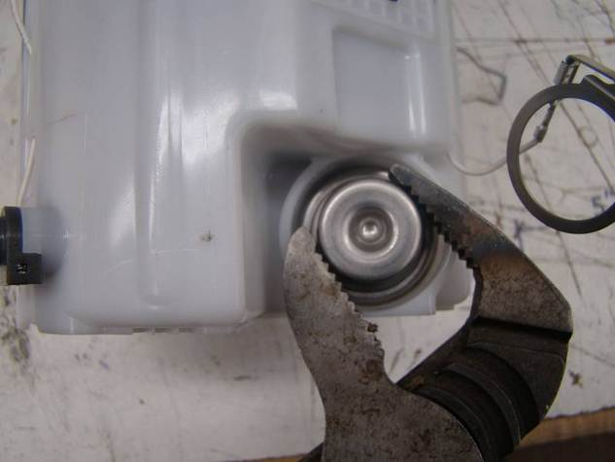
Photo 2: Note the grounding ring has been pushed aside. There are no internal parts that retain the fuel pressure regulator.

STEP 3: Insert the Vaporworx P/N FPRAGM5 into the small hole inside of the fuel module as seen in Photo 3. A small amount of motor oil should be placed on the seal to facilitate assembly. Push the FRPA until it fully seats as shown in Photo 4. In some cases the fuel filter may be partially blocking the hole. If the filter interferes with installation of the FPRA use a long round Phillips screwdriver to gently push the filter away from the hole. It may also be necessary to start the FPRA at a slight angle away from the filter in order to reduce the chances of damage.

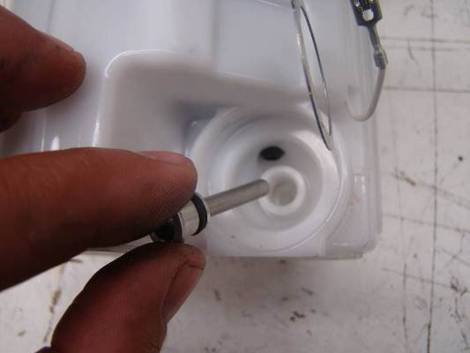
Photo 3: Insert the FPRAGM5 into the small hole until fully seated. If the fuel filter interferes with easy installation use a Philips screwdriver to move to the side (left in the photo.)

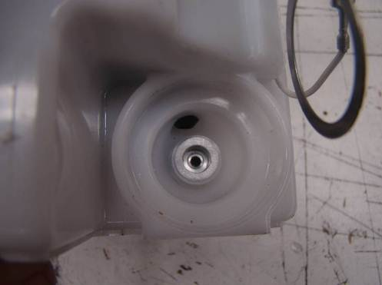
Photo 4: The FPRA is fully seated in the fuel module.

STEP 4: Apply a small amount of oil on both of the new fuel pressure regulator o-rings. The regulator should look similar to that in Photo 5. The extra hardware included with the new regulator will not be used. Note that the large O-ring stands off the flange by approximately 1/8” and that the small O-ring is installed on the regulator. Both O-rings must be installed on the pressure regulator during installation.

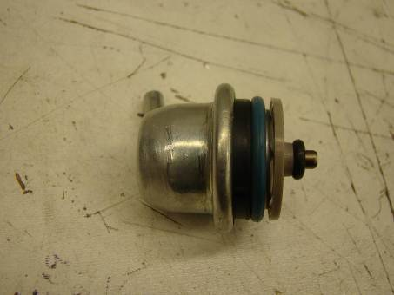
Photo 5: The ready-to-install fuel pressure regulator.

STEP 5: Bend the wire retainer using needle-nose pliers as shown in Photo 6A so that the open ends of the retainer are ¼” apart when not compressed. Insert the regulator, clocked as shown in Photo 6B, until fully seated. Re-install the ground strap and the retaining wire. Continue the retaining wire installation until the ends of the wire fit through the holes/slots on the fuel module body. It may be necessary to push down on the wire end and lightly tap on the head of the wire to fully seat the wire (Photo 7.)

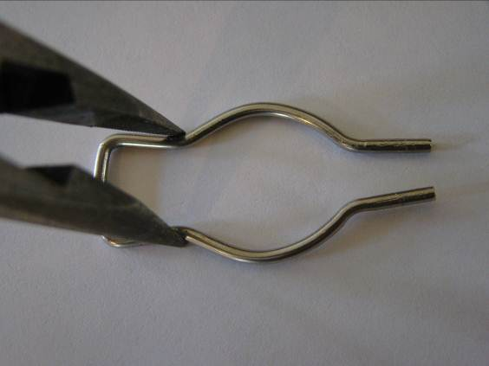
Photo 6A. Bend the retaining clip so that the points of the clip are ¼” apart when not compressed by the needle-nose pliers.

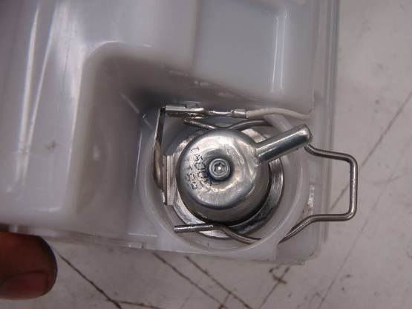
Photo 6b: The new regulator is inserted, the ground strap installed, and the retaining wire partially seated. The ends of the wire are close to the holes/slots in the fuel module body. The ends must go into the holes/slots.

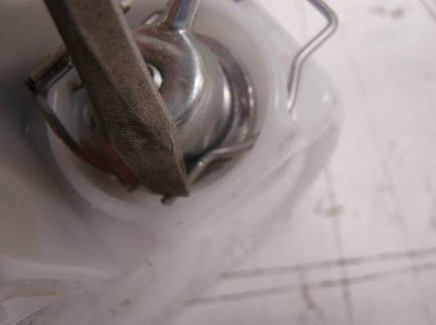
Photo 7: In some cases it may be necessary to push down on the end of the retaining wire ends to align them to the holes/slots in the module body. Take care to keep the ground wire under the retaining wire.

STEP 6: Fully seat the retaining wire. After seating use a pair of needle nose pliers to squeeze the wire ends together, making them fit the body of the regulator better, as seen in Photo 8.

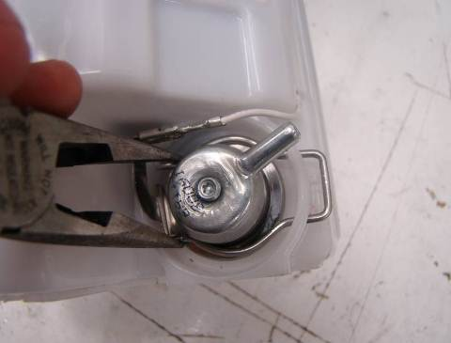
Photo 8: Squeeze the ends of the retaining wire together to help fit them to the regulator body. When complete the head of the retaining wire will be seated against the fuel module.

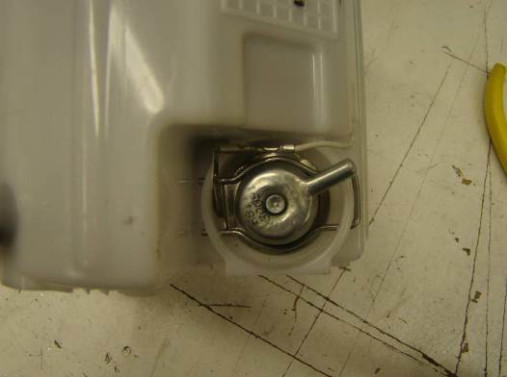

Photo 9: Installation complete.
-----------------------------------------------------------------------------------------------------------

Instructions for adapting the VaporWorx P/N G8/ZL1 WHS wiring pigtail to the OE G8 harness.

The VaporWorx G8/ZL1 wiring pigtail is intended to be used to adapt the Gen5 Camaro ZL1 fuel module power and fuel level sensor requirements into the Pontiac G8 harness. Properly connecting the power and fuel level sensor wiring will require some method of making a secure connection to the G8 harness. This is usually done by cutting/soldering or butt connectors. It is imperative no matter what method is used that the connections are fully insulated from each other and from other components in the car. Any short may lead to damaged wiring or fires.

In Photo 1 the wiring colors for the pigtail can be seen.

- 12ga Red = Pump +. This wire connects to the G8 14ga grey wire for pump power.
- 12ga Black = Pump -. This wire connects to the G8 pump ground wire.
- 20ga Brown = Fuel level sensor. This wire connects to the G8 Brown/Yellow fuel level sensor wire.
- 20 Purple = Fuel level sensor. This wire connects to the G8 Purple fuel level sensor wire.

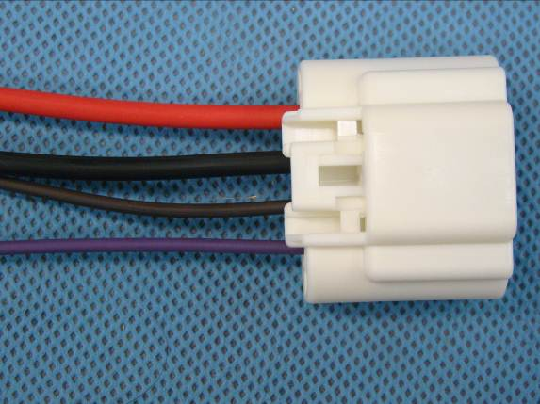

Photo 1: The G8/ZL1 wiring adapter pigtail.

Step 1: Remove the OE G8 plug from the original fuel module.

Step 2: Peel back or remove the wire coverings in order to access the four wires noted above.

Step 3: Access the necessary wires and remove the OE plug. Since the VaporWorx pigtail has long leads it is suggested that the wiring be cut in such a way that the OE plug can be re-attached in the future if needed. 2-3” plug leads should be sufficient for future attachment.

Step 4: If butt connectors are to be used a proper crimping tool and crimping techniques are required to make a reliable connection. Follow the manufacturer’s instructions for proper wire stripping lengths and crimping procedures.

Step 5: If the wiring is to be soldered together it is suggested that a non-insulated crimp be used first to mechanically join the wires. Apply solder to the crimp to secure the wiring. Do not over-apply the solder as it can wick and create a brittle condition. Double wall heat shrink tubing is an excellent choice to use as an insulator. It is available at most electronic stores or Del City.

Step 6: After connecting the wiring as noted above and insulating all connections, apply tape, split tubing, vinyl wrap, etc. to the wiring to protect them from rubbing damage.

------------------------------------------------------------------------------------------------------------

Instructions for installing the VaporWorx P/N G8/ZL1 Adapter Fitting to the Gen5 ZL1 fuel module.

The VaporWorx G8/ZL1 Adapter Fitting is intended to be used to adapt the Pontiac G8 in-tank fuel crossover line to the Gen5 ZL1 fuel module P/N 13579899/19258436 venturi pump connector. Using this adapter eliminates the need for cumbersome brass fittings and in-tank rated rubber fuel lines.

In Photo 1 below the adapter fitting is shown with the retaining clip installed.

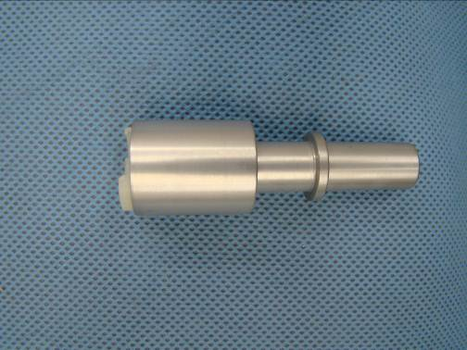
Photo 1: G8/ZL1 Adapter Fitting with the retaining clip installed.

Step 1: Remove the retaining clip from the adapter body and slide it on the ZL1 fuel module venture pump nipple as shown in Photo 2.

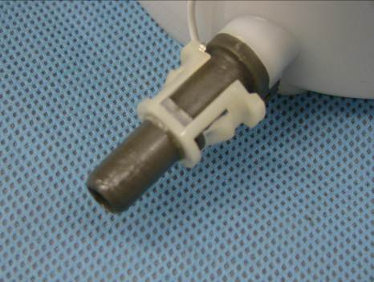
Photo 2. Install the retaining clip as shown. It should clip on over the upset on the nipple.

Step 2: Push the adapter fitting on to the nipple until it seats on the retaining clip as shown in Photo 3. Be sure to press straight into the connector. Do not apply a side load or else the nipple may break.

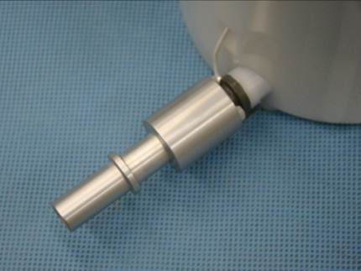
Photo 3. The connector is fully installed. Only push axially on the fitting, do not apply any radial/side load during installation.

The adapter is now ready to re-attach to the G8 in-tank fitting.

